ABC DNSSEC Key Ceremony Scripts

Abbreviations
KMF= Key Management Facility
TEB = Tamper Evident Bag (large DIEBOLD item #00051991000C small #00051991000A)
HSM = Hardware Security Module
FD = Flash Drive
SO = Security Officer
SA = System Administrator
SC = Safe Controller
IW= Internal Witness
EW= External Witness
MC= Master of Ceremonies

Participants
Instructions: At the end of the ceremony, participants print name, citizenship, signature, date, time, and time zone on SO’s copy.

Title | Printed Name | Signature | Date | Time
Sample | Bert Smith | Bert Smith | 12 Jul 2010 | 18:00 UTC
SA
SO
SC
IW
MC
EW1
EW2
EW3

Participants Arrive
Step | Activity | Initial | Time
1 | SA escorts SO, SC, IW and other authorized personnel into the KMF after starting cameras.

Sign into KMF
Step | Activity | Initial | Time
2 | SA has all participants sign into the KMF log.

Emergency Evacuation Procedures
Step | Activity | Initial | Time
3 | SA reviews emergency evacuation procedures with participants.

Verify Time and Date
Step | Activity | Initial | Time
4 | IW enters date (month/day/year), UTC time using a reasonably accurate wall clock visible to all here:  Date (UTC): ___________________Time (UTC): _____________________  All entries into this script or any logs should follow this common source of time.

Open KMF Safe
Step | Activity | Initial | Time
5 | SC, while shielding combination from camera, opens KMF Safe.
6 | SC takes out safe log and prints name, date, time, signature, and reason (i.e. “open safe”) in safe log. IW initials this entry.
Remove Equipment from KMF Safe
Step | Activity | Initial | Time
7 | SO removes blank smartcards (in TEB) from the safe and completes the next entry in the safe log indicating removal with “Blank Smartcard Removal,” TEB #, printed name, date, time, and signature. IW initials this entry.
8 | SA removes card reader (in TEB) from the safe and completes the next entry in the safe log indicating removal with “Card Reader Removal,” TEB #, printed name, date, time, and signature. IW initials this entry.
9 | SA takes out the TEB with the O/S DVD from the safe and completes the next entry in the safe log indicating its removal with “DVD Removal,” TEB #, printed name, date, time, and signature. SA places the item on KMF table. IW initials this entry.
10 | SA takes out the TEB with blank, labeled (HSMFD), flash drives from the safe and completes the next entry in the safe log indicating its removal with “HSMFD Removal.” TEB #, printed name, date, time, and signature. SA places the item on KMF table. IW initials this entry.
11 | SA takes out the TEB with laptop from the safe and completes the next entry in the safe log indicating its removal with “Laptop Removal,” TEB #, printed name, date, time, and signature. SA places item on KMF table. IW initials this entry.
12 | SA removes any power supply units, cables and other equipment necessary from safe and places them on KMF table.

Close KMF Safe
Step | Activity | Initial | Time
13 | SC makes an entry including printed name, date, time and signature into the safe log indicating closing of the safe. IW initials this entry.
14 | SC places safe log back in safe and closes and locks safe.
15 | SO and SA verify that the safe is locked.

Set Up Laptop
Step | Activity | Initial | Time
16 | SA inspects the O/S DVD TEB for tamper evidence; reads out TEB # while participants match it with the prior script entry.  TEB#
17 | SA inspects the laptop TEB for tamper evidence; reads out TEB # while participants match it with the prior script entry.  TEB#
18 | SA takes O/S DVD and laptop out of TEBs placing them on KMF table; discards TEBs; connects laptop power, external display, printer and boots laptop from DVD.
20 | SA configures external display for participants to see.
21 | SA logs in as root
22 | SA configures printer as default and prints test page.
24 | SA opens a second window and executes  sha256sum /dev/cdrom  To verify the authenticity of the DVD. The SA may continue with other elements while this computation is taking place by returning to the first window. The sha256 hash for caribnog.iso should be:  3c1f7-PUT-your-DVD-HASH-HERE-4324234
25 | SA verifies the time zone, date, and time on the laptop and synchronizes it if necessary. Display the current time and timezone:  date  If the timezone is not set to UTC:  cd /etc/  rm localtime  ln -s /usr/share/zoneinfo/UTC localtime  Set time to match the wall clock:  date mmddHHMMYYYY  Verify:  date
26 | SA inspects the HSMFD TEB for tamper evidence; reads out TEB # while participants match it with the prior script entry.  TEB#
27 | SA takes HSMFDs out of TEB; discards TEB; and plugs it into free USB slot.  The O/S should recognize the FD as /media/HSMFD  If the FD is not recognized, SA mounts the HSMFD using:  mkdir /media/HSMFD  mount /dev/sda1 /media/HSMFD  Where /dev/sda1 should be the FD in dmesg output.  Then displays contents to participants using ls –lt /media/HSMFD
Start Logging Terminal Session
Step | Activity | Initial | Time
28 | SA executes  script /media/HSMFD/script–20121001.log  to start a capture of terminal output.
Connecting Card Reader
Step | Activity | Initial | Time
29 | SA inspects the card reader TEB for tamper evidence; reads out TEB # while participants match it with the prior script entry.  TEB#
30 | SA removes reader from TEB; discards TEB; and connects smartcard reader to free USB slot on laptop.

Initializing Smartcards
Step | Activity | Initial | Time
31 | SO inspects the TEB of smartcards for tamper evidence; reads out TEB # while SA matches it with a prior script entry.  TEB#  and removes smartcards from TEB and discards TEB.
32 | SO takes a new smartcard and plugs it into card reader. Light on reader should flash.
33 | SO initializes the smartcard by running  carderase  SO enters new 8 digit long PIN while shielding from camera. If reusing a previously initialized card, you may be asked for “Security Officer PIN”. Respond with PIN used previously for this card. Note: For our configuration, PIN, PUK, and SO PIN are made equal.
34 | SO executes  cardshow  to display contents of card.

Start Hardware Random Number Generator (RNG)
Step | Activity | Initial | Time
35 | SA starts RNG by opening a new terminal window and executing  cardrng  SO enters PIN when requested.
36 | SA tests RNG by returning to the script window and executing  rngtest < /dev/random  waiting at least 10 seconds; then hitting CTRL-C. The number of successful tests should greatly exceed any failures, if any. During the test, the RNG window should be displaying dots indicating the feeding of random numbers into the kernel.

Generate New ZSKs
Step | Activity | Initial | Time
37 | To generate ZSK in ram disk, SA runs  export DOMAIN=py  export TEST=yes  genzsk  and enters password to protect private half of ZSKs.  Note that cardrng window should show “…” indicating activity.  The list of generated key file names can be found in genzsk.out. The public ZSKs end in .key. The corresponding encrypted private halves end in .private.aes256. SA may display directory contents using ls -lt

Generate a New KSK and put on Smartcards
Step | Activity | Initial | Time
38 | To generate KSK in ram disk, SA runs  genksk  and enters “temp” as filename.
39 | SA puts stationery into printer and runs  enscript --copies=N [-p out.ps] temp.out  and hands printouts to participants. “N” is the number of copies.
40 | SA reads out the displayed public key hash from terminal while participants match this to the printouts to ensure what is displayed is properly captured in the printouts that participants will take with them to verify and attest that the KSK generated in this ceremony is the one deployed in the DNS.
41 | SA asks “does anyone object”?
42 | IW attached a printout to his/her script.
43 | SA stops RNG by going to RNG terminal window and hitting CTRL-C then entering “exit”.
44 | SO runs  cardwrite  and enters “temp” for KSK file, Kpy20121001 for CKA_LABEL, and 2 for CKA_ID followed by PIN when prompted to write the new KSK to smartcard.
45 | SO then executes  cardshow  To verify contents of card to see private and public keys labeled Kpy20121001.  SO removes card labeling it with Kpy20121001, date, and “KSK 1 of 3”.  SO then writes same information along with printed name and signature on a new TEB and places card in TEB and seals it. Finally, the SO writes TEB#, and CKA_LABEL here:  Description: KSK 1 of 3  TEB# _____________________________________________________  CKA_LABEL Kpy20121001  IW initials TEB.
46 | SO takes a new smartcard and plugs it into card reader. Light on reader should flash.
47 | SO initializes the smartcard by running  carderase  SO enters same PIN above while shielding from camera.
48 | SO runs  cardwrite  and enters “temp” for KSK file, Kpy20121001 for CKA_LABEL, and 2 for CKA_ID followed by PIN when prompted to write the new KSK to smartcard.
49 | SO then executes  cardshow  To verify contents of card to see private and public keys labeled Kpy20121001.  SO removes card labeling it with Kpy20121001, date, and “KSK 2 of 3”.  SO then writes same information along with printed name and signature on a new TEB and places card in TEB and seals it. Finally, the SO writes TEB#, and CKA_LABEL here:  Description: KSK 2 of 3  TEB# _____________________________________________________  CKA_LABEL Kpy20121001  IW initials TEB.
50 | SO takes a new smartcard and plugs it into card reader. Light on reader should flash.
51 | SO initializes the smartcard by running  carderase  SO enters same PIN above while shielding from camera.
52 | SO runs  cardwrite  and enters “temp” for KSK file, Kpy20121001 for CKA_LABEL, and 2 for CKA_ID followed by PIN when prompted to write the new KSK to smartcard.
53 | SO then executes  cardshow  To verify contents of card to see private and public keys labeled Kpy20121001.  SO removes card labeling it with Kpy20121001, date, and “KSK 3 of 3”.  SO then writes same information along with printed name and signature on a new TEB and leaves it on the table for later use. Finally, the SO writes TEB#, and CKA_LABEL here:  Description: KSK 3 of 3  TEB# _____________________________________________________  CKA_LABEL Kpy20121001
Delete Private Key File
Step | Activity | Initial | Time
54 | SA deletes private key file from ram disk* by running  shred -u temp  *Note: due to the underlying automated management techniques, deletion cannot be guaranteed on flash media
- KSK Generation Complete -
- DNSKEY RRset Signing -
Signing DNSKEY RRsets
Step | Activity | Initial | Time
55 | SO inserts smartcard KSK 3 of 3 from above in reader and runs  cardsign  CKA_LABEL is the value used above or Kpy20121001  When asked for PIN, SO enters it while hiding it from cameras.  This will generate KSK signed DNSKEY RRsets and ZSKs in encrypted files of the form 20121001hhmmss.py.keybundle.tar.gz.aes256 at least one ZSK rollover.
56 | SA runs  enscript --copies=N tt.dnskeyrrset.9  and hands printouts to participants for them to verify and attest that the ZSKs generated in this ceremony are the ones that get deployed in the DNS. DNSKEY RRset 9 will have the public keys from both what will be the current ZSK and what it will roll to at the next rollover cycle.
57 | IW attaches a printout to his/her script.
58 | SO removes smartcard from reader and places card in “KSK 3 of 3“ TEB created for it above and seals it. IW initials TEB.
59 | SA runs  tar zcf /media/HSMFD/kc20121001.tar.gz .  to archive all results and ZSK+DNSKEY RRsets destined for signer and DS records for parent zone.
- DNSKEY RRset Signing Complete -

For Demonstration Only
Step | Activity | Initial | Time
XX | SA executes  signzone  This will create a test zone, add DNSKEY RRset, decrypt ZSKs above. SA may display live output from signer process using  tail –f /tmp/namedb/signemd.out  (for this demo) or  monitor  to simply view ZSK and KSK key tags using “dig”.
Stop Logging Terminal Output
Step | Activity | Initial | Time
60 | SA stops logging terminal output by entering “exit” in terminal window

Backup HSM FD Contents
Step | Activity | Initial | Time
61 | SA displays contents of HSMFD by executing  ls –lt /media/HSMFD
62 | SA plugs a blank HSMFD into the laptop, then waits for it to be recognized by the O/S as /media/HSMFD_ and copies the contents of the original HSMFD to the blank drive for backup by executing  cp -Rp /media/HSMFD/* /media/HSMFD_  Note:If only unprepared FDs are available, the SA may follow the following steps to format and label:  - Plug FD in  - Unmount FD if auto mounted by O/S  - determine device name using dmesg (should be /dev/sdb1)  - execute mkfs.vfat –n HSMFD /dev/sdb1  - remove FD  - re-insert FD and wait for O/S to recognize as above
63 | SA displays contents of HSMFD_ by executing  ls –lt /media/HSMFD_
64 | SA unmounts new HSMFD using  umount /media/HSMFD_
65 | SA removes HSMFD_ and places on table.
66 | SA repeats steps above and creates 4 more copies.

Returning HSMFD to a TEB
Step | Activity | Initial | Time
67 | SA unmounts HSMFD by executing  umount /media/HSMFD
68 | SA removes HSMFD and places it in new TEB and seals; reads out TEB #; shows item to participants and IW records TEB # here  TEB # ______________________________________________________  and places it on KMF table.

Returning O/S DVD to a TEB
Step | Activity | Initial | Time
69 | After all print jobs are complete, SA executes  shutdown –hP now  removes DVD and turns off laptop.
70 | SA places DVDs in new TEB and seals; reads out TEB #; shows item to participants and IW records TEB # here.  TEB# _______________________________________________________  and places it on KMF table.

Returning Laptop to a TEB
Step | Activity | Initial | Time
71 | SA disconnects card reader, printer, display, power, and any other connections from laptop and puts laptop in new TEB and seals; reads out TEB #; shows item to participants and IW records TEB # here.  TEB# _______________________________________________________  and places it on KMF table.

Returning Card Reader to a TEB
Step | Activity | Initial | Time
72 | SA places card reader in new TEB and seals; reads out TEB #; shows item to participants and IW records TEB # here.  TEB# _______________________________________________________  and places it on KMF table.
Returning Equipment in TEBs to KMF Safe
Step | Activity | Initial | Time
73 | SC opens safe shielding combination from camera.
74 | SC removes the safe log and fills the next entry with printed name, date, time, and signature indicating the opening of the safe. IW initials the entry.
75 | SO records return of KSK 3 of 3 in next entry field of safe log with TEB #, printed name, date, time, and signature. Places item in safe. IW initials the entry.
76 | SO records return of KSK 2 of 3 in next entry field of safe log with TEB #, printed name, date, time, and signature. Places item in safe. IW initials the entry.
77 | SO records return of KSK 1 of 3 in next entry field of safe log with TEB #, printed name, date, time, and signature. Places item in safe. IW initials the entry.
78 | SA records return of card reader in next entry field of safe log with TEB #, printed name, date, time, and signature; places the card reader into safe and IW initials the entry.
79 | SA records return of laptop in next entry field of safe log with TEB #, printed name, date, time, and signature; places the laptop into safe and IW initials the entry.
80 | SA records return of HSMFD in next entry field of safe log with TEB #, printed name, date, time, and signature; places the HSMFD into safe and IW initials the entry.
81 | SA records return of O/S DVD in next entry field of safe log with TEB #, printed name, date, time, and signature; places the O/S DVD into safe and IW initials the entry.
82 | SA returns remaining power supplies, adaptors, and cables to safe. No entry in log is necessary.

Closing KMF Safe
Step | Activity | Initial | Time
83 | SC makes an entry including printed name, date, time, signature and notes closing safe into the safe log. IW initials the entry.
84 | SC places log back in safe and locks safe.
85 | SO and SA verify safe is locked.

Participant Signing of IW’s Script
Step | Activity | Initial | Time
86 | All EWs enter printed name, date, time, and signature on IW’s script coversheet.
87 | SA, SC, SO review IW’s script and signs it.

Signing out of Ceremony Room
Step | Activity | Initial | Time
88 | SA ensures that all participants sign out of KMF sign-in log and are escorted out of the KMF.

Filming Stops
Step | Activity | Initial | Time
89 | SA stops filming.

Copying and Storing the Script
Step | Activity | Initial | Time
90 | IW makes at least 5 copies of his or her script: one for off-site audit bundle, one for on-site audit bundle, one for IW, and copies for other participants, as requested.  Audit bundles each contain 1) output of signer system - HSMFD; 2) copy of IW’s key ceremony script; 3) audio-visual recording; 4) SA attestation (A.2 below); and 5) the IW attestation (A.1 below) - all in a TEB labeled “Key Ceremony”, dated and signed by IW and SA. One bundle will be stored by the SA at the KMF – typically in the same area as the safe. The second bundle will be kept securely by the IW at a bank safe deposit box.

All remaining participants sign out of ceremony room log and leave.

Appendix A.1:

Key Ceremony Script

(by IW)

I hereby attest that the Key Ceremony was conducted in accordance with this script and any exceptions which may have occurred were accurately and properly documented.

Printed Name: _________________________________________

Signature: _________________________________________

Date: _________________________________________
Appendix A.2:

Access Control System Configuration Review

(by SA)

I have reviewed the physical access control system and not found any discrepancies or anything else out of the ordinary.

Enclosed is the audited physical access log.

Printed Name: _________________________________________

Signature: _________________________________________

Date: _________________________________________

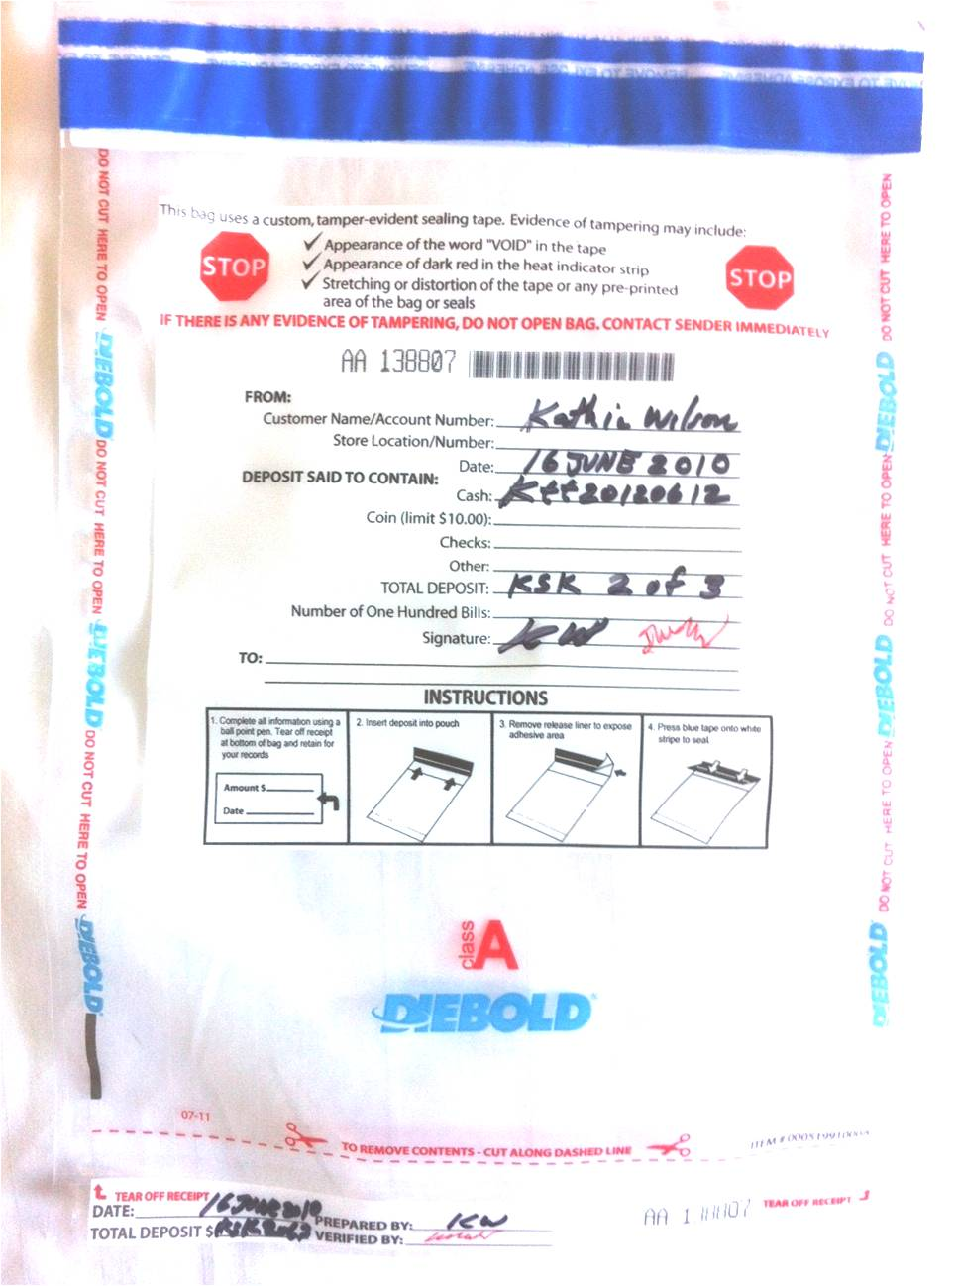

A | Alfa | AL-FAH
B | Bravo | BRAH-VOH
C | Charlie | CHAR-LEE
D | Delta | DELL-TAH
E | Echo | ECK-OH
F | Foxtrot | FOKS-TROT
G | Golf | GOLF
H | Hotel | HOH-TEL
I | India | IN-DEE-AH
J | Juliet | JEW-LEE-ETT
K | Kilo | KEY-LOH
L | Lima | LEE-MAH
M | Mike | MIKE
N | November | NO-VEM-BER
O | Oscar | OSS-CAH
P | Papa | PAH-PAH
Q | Quebec | KEH-BECK
R | Romeo | ROW-ME-OH
S | Sierra | SEE-AIR-RAH
T | Tango | TANG-GO
U | Uniform | YOU-NEE-FORM
V | Victor | VIK-TAH
W | Whiskey | WISS-KEY
X | Xray | ECKS-RAY
Y | Yankee | YANG-KEY
Z | Zulu | ZOO-LOO
1 | One | WUN
2 | Two | TOO
3 | Three | TREE
4 | Four | FOW-ER
5 | Five | FIFE
6 | Six | SIX
7 | Seven | SEV-EN
8 | Eight | AIT
9 | Nine | NIN-ER
0 | Zero | ZEE-RO

ABC DNSSEC Script Exception

Abbreviations
TEB = Tamper Evident Bag
HSM = Hardware Security Module
FD = Flash Drive
SO = Security Officer
IW = Internal Witness
EW= External Witness
SA = System Administrator
SC = Safe Controller
Instructions: Initial each step that has been completed below, e.g., BTS. Note time.
Note Exception Time
Step |  | Activity |  | Initial |  | Time
1 | IW notes date and time of key ceremony exception and signs here: ____________________________________________________
2 | IW Describes exception and action below

– End of DNSSEC Script Exception –

